2022 Sexual Harassment Prevention Training Course Instructions
Follow the instructions below to complete the online training course via UB Learns
UB Learns Website Link: https://ublearns.buffalo.edu/
*Important note: This course will not work when using the Internet Explorer (IE) internet browser.
Verify that your internet browser is compatible. To use UB Learns, use a computer that is connected to the Internet and the most up-to-date web browser. It is recommended that you use the most current version of:
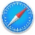
Chrome Safari
Firefox Microsoft Edge
Blackboard technical support offers a list of certified and compatible browsers, listed by Operating System, for use with Blackboard (UB Learns). Blackboard Compatible Browsers (UB Learns).
Accessing the Course
- Go to UB Learns and select “Login”.
  - Enter your UBIT Name and Password Click Login.
To look up your UBIT Name please go to: https://www.buffalo.edu/search/you

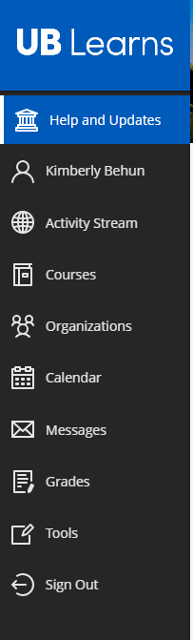
- Select Courses in the left navigation menu.
If you do not see the left navigation menu, make sure you are viewing the page in a full screen mode.
- Select the UB Learns Course Catalog link displayed on the top-right corner of the page.

- Search for the course by entering edishp in the Search Catalog text box and select Go.
The UB Sexual Harassment Prevention Training Course will be displayed.
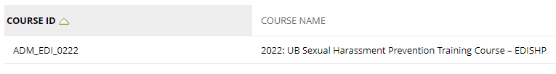
- Self-Enroll in the course.
  - Select course AMD_EDI_0222 and a down arrow will appear.
  - Select the down arrow and then Enroll (will only see the down arrow by hovering over the name).
  - Click the Submit link at the bottom left to proceed.
A window will appear confirming you have successfully enrolled in the course.
  - Select the OK link found at the bottom right side of the screen.
- Read the Message from the President.
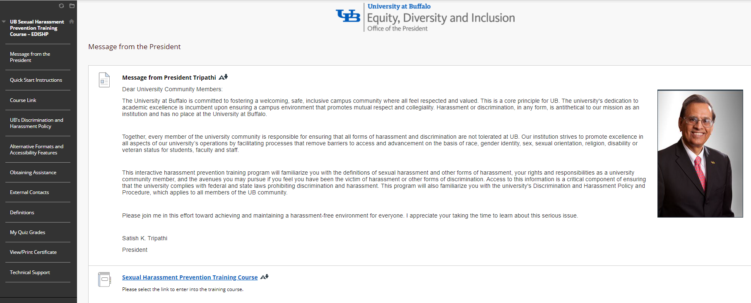
- To start the course:
Select the Sexual Harassment Prevention Training Course link. This is located both below the Message from the President and on the Course Link tab in the left navigation menu.
For more detailed course instructions, select the Quick Start Instructions on the left-side navigation menu. You may also access the course link at the bottom of these bulleted instructions.
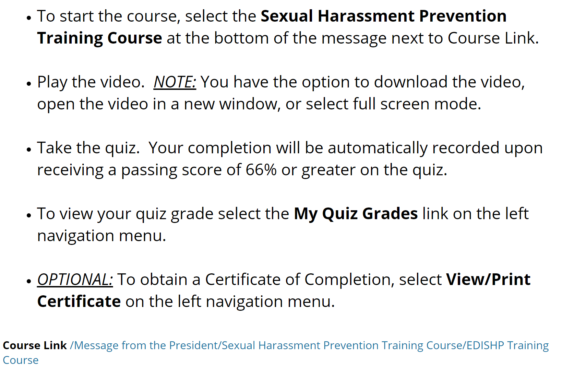

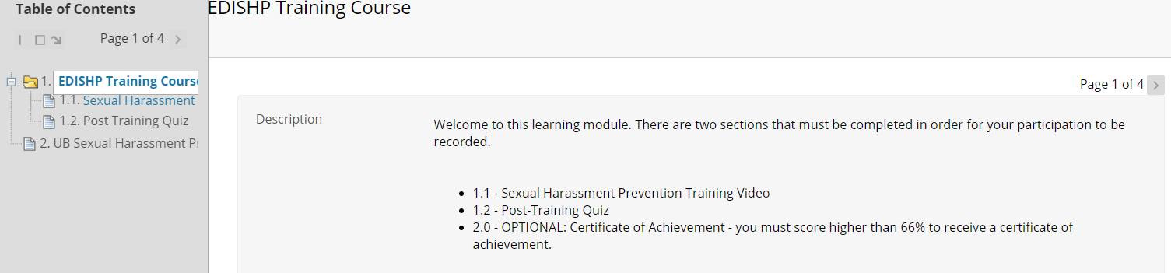
- To navigate the course, select the right arrow to advance through the course pages.
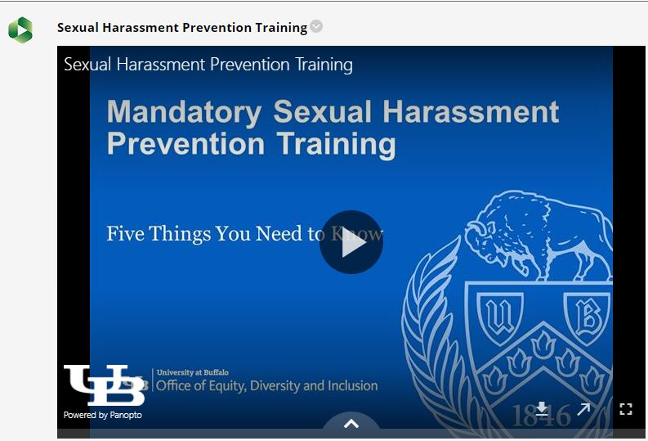
- Page 2: Play the Sexual Harassment Prevention Training Video
Start the training by selecting the play button in the middle of the screen.
You may choose to watch the video by downloading the video, opening the video in a new window or by making the video full sized.
Download
New Window
Full Size

  - Panopto is the video platform that was used to create the training video. The software requires your internet browser to accept third-party cookies. The Safari internet browser in particular may require you to change your settings in order to view this type of video file.
If you are using an Apple device (i.e. MacBook, iMac, iPad or iPhone) and the Safari browser, please review the following information regarding Panopto and the Safari internet browser:
How to enable support for Third Party browsers
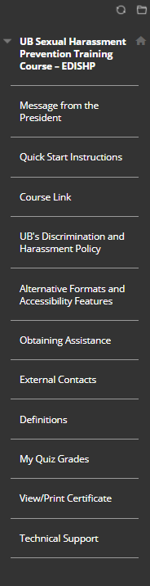
  - Alternative Formats and Accessibility Features:
For additional information, refer to the Alternative Formats and Accessibility Features found in the left navigation menu.
When you have finished the video, please select the arrow to the right of the number 3.

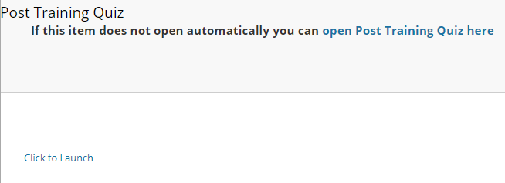
- Page 3: Post Training Quiz
If the quiz does not automatically launch please select the Click to Launch link.

- Take the quiz.
  - Select the Begin link that is displayed on the bottom right of the page.
  - Answer all the questions displayed.
  - Select the Save and Submit link displayed on the bottom right of the page.
  - A “test submitted” message will appear.
  - Select the OK link displayed on the bottom right of the page.
  - Your quiz score and graded answers are displayed along with an explanation for each question.
  - You are required to achieve a minimum of four correct answers (above 66%) to complete the course. If you did not achieve this, you may select the OK link displayed on the bottom right of the page and relaunch the quiz to try again.
  - Once you have achieved a passing quiz score, select the OK link displayed on the bottom right of the page. You have completed the course, and your completion record will automatically register. You’ve completed the course!
* To view your quiz grade:
- To view your quiz grade, select My Quiz Grade from the left navigation menu in UB Learns.
- Select My Grades. Your grade will be displayed.
- You may retake the quiz if your grade is below a 66%.

*Optional Certificate of Completion:
You do not need to submit a Certificate of Completion to the Office of Equity, Diversity and Inclusion (EDI). Your completion will be automatically recorded upon completion of the previous steps.
If you would like to create and/or print a Certificate of Completion for your own records or to provide to another employer, select View/Print Certificate in the left navigation menu in UB Learns.
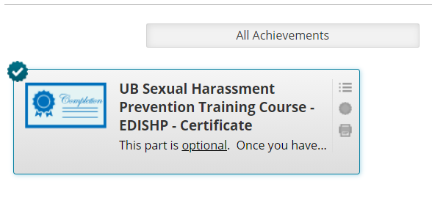
To print your certificate, select the printer icon. Sign out of UB Learns
- Select Sign Out in the left navigation menu in UB Learns.
- Close all internet tabs.

For Mobile Phones or Tablets – Accessing UB Learns from your portable device
UB Learns does not support enrollment in the course on its mobile app. Please take the annual Sexual Harassment Prevention Training on a desktop, PC, or laptop device. If you are unable to do so, please contact EDI for assistance.

